IC MICE

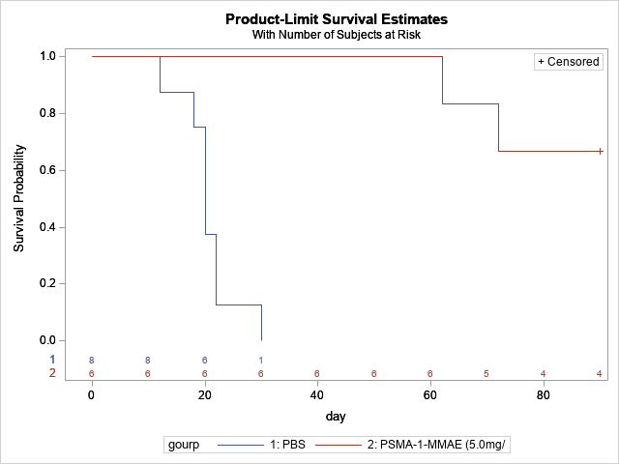

|  |  |  |  |  |
| --- | --- | --- | --- | --- |
| Adjustment for Multiple Comparisons for the Logrank Test | | | | |
| Strata Comparison | | **Chi-Square** | **p-Values** | |
| gourp | **gourp** | **Raw** | **Sidak** |
| PBS | **PSMA-1-MMAE (5.0mg/** | 12.9646 | 0.0003 | 0.0003 |

MMAE

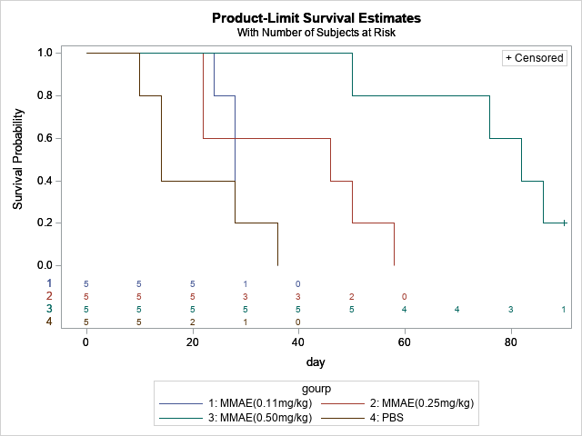

|  |  |  |  |  |
| --- | --- | --- | --- | --- |
| Adjustment for Multiple Comparisons for the Logrank Test | | | | |
| Strata Comparison | | **Chi-Square** | **p-Values** | |
| gourp | **gourp** | **Raw** | **Sidak** |
| MMAE(0.11mg/kg) | **MMAE(0.25mg/kg)** | 0.2115 | 0.6456 | 0.9980 |
| MMAE(0.11mg/kg) | **MMAE(0.50mg/kg)** | 9.3481 | 0.0022 | 0.0133 |
| MMAE(0.11mg/kg) | **PBS** | 0.3651 | 0.5457 | 0.9912 |
| MMAE(0.25mg/kg) | **MMAE(0.50mg/kg)** | 5.1007 | 0.0239 | 0.1352 |
| MMAE(0.25mg/kg) | **PBS** | 1.1361 | 0.2865 | 0.8680 |
| MMAE(0.50mg/kg) | **PBS** | 15.4432 | <.0001 | 0.0005 |